Instruction Manual

Fork Hook

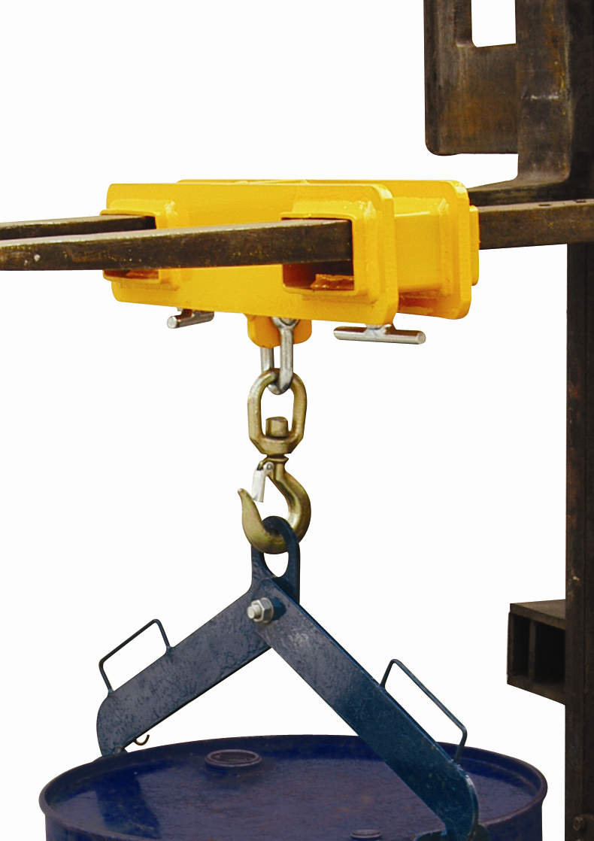

Note: The Owner/Operator must read carefully and understand all the information presented here before operation.

THANK YOU FOR USING THIS FORK HOOK. FOR YOUR SAFETY AND CORRECT OPERATION, PLEASE CAREFULLY READ THIS INSTRUCTION BEFORE USING IT.

NOTE: All of the information reported herein is based on data available at the moment of printing. The factory reserves the right to modify its own products at any moment without notice and incurring in any sanction. So it is suggested to always verify possible updates.

MK10/MK25/MK50 is a kind of special tool which designed for hoisting. For your safety and correct operation, please carefully read this instruction before using it and operate it following the instructions. If you have any questions after reading this manual, please contact your supplier in time.
1. PACKING
This fork hook is packed with soft material. Please check carefully whether there is something damaged because of transporting or other problems when opening the packing. If does, please fill in the complaint list and send it to your provider in 24 hours. Make sure note its order number.
2. SAFETY OPERATION
Warning: The product is designed for special usage. Please pay attention to the following items to ensure your proper operation.
2.1 Never overload the fork hook beyond its rated capacity. The max capacity of MK10 is 1ton and MK25 is 2.5ton, MK50 is 5ton.
2.2 It is only used for forklift. Never make it for other use.
2.3 Never modify this product without the permission of the manufacture.
2.4 Never remove or dirty the warning markings.
3. OPERATING INSTRUCTIONS
3.1 Choose a proper fork hook that matches the forklift.
3.2 Insert the forks of forklift into grooves of fork hook horizontally.
3.3 Tighten the T-bolt and lock the chain of hook on the forklift for security.
3.4 Make sure everything is ok and then the forklift can start working.
4. MAINTENANCE
Often check the hook of distortion and damage. Repair it timely if there is some damage.
5. RESPONSIBILITY
Contact the supplier within 9 days if there is something wrong with the product.
6. LIMITED RESPONSIBILITY
The manufacturers disclaim all responsibility for the damage caused by misuse, wrong operation or using without following the instructions.
7. ORDER COMPONENTS
Please contact your supplier if you want to order some components.
- PARAMETER
Model | MK10 | MK25 | MK50
Capacity (kg) | 1000 kg | 2500 kg | 5000kg
Max. Fork Section (mm) | 160×60 | 160×60 | 200×100
Overall Size (mm) | 120×460×130 | 150×660×140 | 180×730×220
Net Weight (kg) | 14 | 25 | 49
9. EXPLODED VIEW & PART LIST
Item | Description | Qty | Notes
1 | Fork hook | 1
2 | Spanner | 2
